
Murarrie State School

2025-2030
Student
Code of Conduct

Equity and Excellence: realising the potential of every student
Equity and Excellence outlines the government's vision for a progressive, high-performing education system. Equity and Excellence provides clarity for schools about priorities and expectations, with differentiated support targeted to each school's context and needs.
Queensland Department of Education

Murarrie State School is committed to providing a safe, responsible, respectful and disciplined learning environment for all students and staff. Students have opportunities to engage in quality learning experiences and acquire values supportive of their lifelong wellbeing.

The ‘Student Code of Conduct’ is designed to facilitate high expectations of behaviour so that the learning and teaching in our school can be effective and students can participate positively within our school community. Its purpose is to facilitate high standards of behaviour from all in the school community, ensuring learning and teaching at Sunnybank Special School is prioritised, where all students are able to experience success and staff enjoy a safe workplace.

Contact Information

Postal address: | 2-26 Garrett Street, Murarrie
Phone: | 07 3908 0333
Email: | admin@murarriess.eq.edu.au
School website address: | https://murarriess.eq.edu.au/

Endorsement

Principal Name: | Alexandra Wallace (Acting)
Principal Signature:
Date:
P/C President: | Candice Stiitt
P/C President Signature:
Date:

Contents

Purpose and Review Statement | 4
Data Overview | 5
School Opinion Survey | 6
Learning and Behaviour Statement | 7
Whole School Approach to Discipline | 11
Consideration to Individual Circumstances | 12
PBL Expectations | 12
Differentiated and Explicit Teaching | 13
Focussed Teaching | 13
Intensive Teaching | 14
Legislative Delegations | 15
Disciplinary Consequences School Disciplinary Absences (SDA) | 16
School Policies | 17
Temporary removal of student property | 18
Use of mobile phones and other devices by students | 19
Preventing and Responding to Bullying | 22
Appropriate use of Social Media | 25
Restrictive Practices | 33
Critical Incidents | 32
Resources | 33
Conclusion | 34

Purpose

Murarrie State School is committed to providing a safe, respectful and disciplined learning environment for all students, staff, parents and visitors.
The Murarrie State School Student Code of Conduct sets out the responsibilities and processes we use in our school to promote a productive, effective whole school approach to discipline. Its purpose is to facilitate high standards of behaviour from all in the school community, ensuring learning and teaching in our school is prioritised, where all students are able to experience success and staff enjoy a safe workplace.

Murarrie State School’s ‘Student Code of Conduct’ outlines our system for facilitating positive behaviours, preventing problem behaviour and responding to unacceptable behaviours. Throughout the school, shared expectations for student behaviour are understood and practiced by everyone, assisting Murarrie State School to create and maintain a positive and productive learning and teaching environment, where ALL school community members have clear and consistent expectations and understanding of their role in the educational process.
The Student Code of Conduct contains information relating to
- Positive Behaviour for Learning (including expectations)
- How we collect behaviour data and how we use it
- Restrictive Practices
- School Policies around how we respond to bullying, appropriate use of mobile phones (Away for the Day) and social media.

Review Statement

The Murarrie State School Student Code of Conduct underwent a full review at the end of 2025 in line with the scheduled review process for the School Planning, Reviewing and Reporting cycle. In addition to this major review, annual minor updates were made to reflect changing circumstances, current data, and staffing.

As part of the 2025–2029 Student Code of Conduct, a Restrictive Practice – Focus Review was included, along with the Queensland Government’s Mobile Phones and Wearable Devices: ‘Away for the Day’ procedure.

Data Overview

This section is used to report on key measures related to student discipline, safety and wellbeing using existing data sets available to all schools, including Murarrie State School. This provides an open and transparent reporting mechanism for the school community on the perceptions of students, parents and staff about school climate, attendance and school disciplinary absences.

The Parent, Student and Staff Satisfaction data in the tables below is drawn from the School Opinion Survey. The School Opinion Survey is an annual collection designed to obtain the views of parents/caregivers, students and school staff from each school on what they do well and how they can improve.

Opinions on the school, student learning, and student wellbeing are sought from a parent/caregiver in all families and a sample of students from each state school.

Opinions on the school as a workplace are sought from all school staff and principal. There are additional questions for teaching staff on their confidence to teach and improve student outcomes. Principals are also asked about their confidence to lead the school and improve student outcomes.

There are four different confidential surveys for
- Parents
- Students
- Staff
- Principals

School Opinion Survey
Parent Opinion Survey

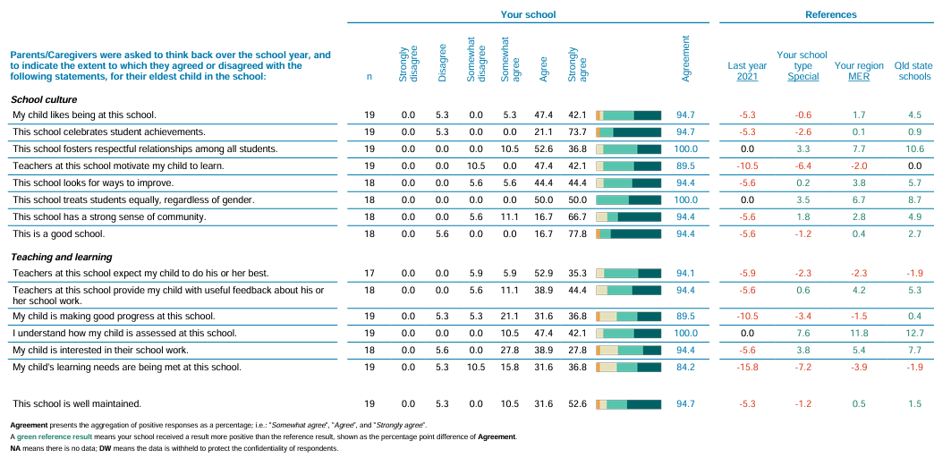

Staff Opinion Survey

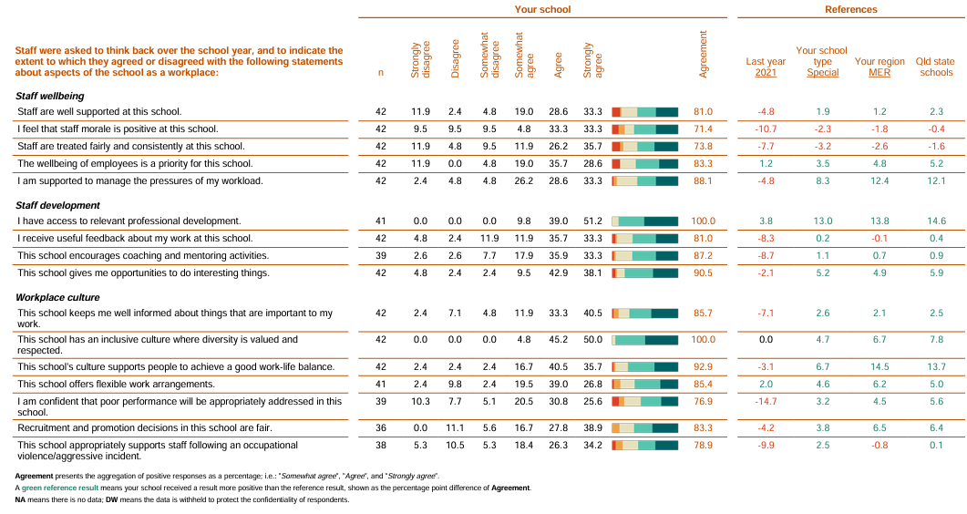

Learning and Behaviour Statement

All areas of Murarrie State School are learning and teaching environments. We consider positive behaviour management to be an opportunity for valuable social learning as well as a means of maximising the success of academic education programs. We believe in the importance of explicit teaching of school wide expectations and dedicate classroom teaching time to this as well as during weekly assemblies. Our school - wide framework for managing behaviour is Positive Behaviour for Learning (PBL).

Our Student Code of Conduct outlines our school system for facilitating positive behaviours, preventing problem behaviours and responding to unacceptable behaviours. Our three expectations for student behaviour are understood and practised by everyone, assisting Murarrie State School to create and maintain a positive and productive learning and teaching environment, where ALL school community members have clear and consistent expectations and understandings of their role in the educational process.

Multi-Tiered Systems of Support

Murarrie State School uses multi-tiered systems of support (MTSS) as the foundation for our integrated approach to learning and behaviour. MTSS is a preventative, differentiated model grounded in practical strategies, targeted planning and data-informed decision-making. Based on a problem-solving model, in MTSS school staff match increasingly intensive interventions to the identified needs of individual students. The MTSS that Sunnybank Special School uses is:
- Universal Behaviour Support
- Targeted Behaviour Support
- Intensive Behaviour Support

Tier | Prevention Description
1 | All students (100%) in the school receive support for their academic and behavioural development. Focus is on the whole-school implementation of both the Australian Curriculum and Positive Behaviour for Learning (PBL) expectations.  This involves:  - teaching behaviours in the setting they will be used in  - being consistent when addressing challenging behaviour, while taking developmental norms and behavioural function into account  - providing refresher lessons and targeted recognition throughout the year, on a weekly basis throughout the school year, so skills are ready and likely to be used when students need them. This is conducted through IMovie’s, visuals, speech and expectations displayed in the playgrounds and classrooms  - asking students and their families for their perspectives on school climate, instruction, reinforcement, and discipline so improvements in Tier 1 may be made.
2 | Targeted instruction and supports for some students (10-15%) are more intense than Tier 1 services, providing more time and specialisation in services from a range of school-based staff to enable students to meet the required academic and behavioural standards.  Tier 2 supports build on the lessons provided at Tier 1, and may prevent the need for more intensive interventions. Tier 2 supports are provided to small groups of students with similar needs, offering more time and/or detailed instruction on the Australian Curriculum or particular aspects of Positive Behaviour for Learning (PBL) expectations. The types of interventions offered at this level will vary according to the needs of each school’s student body, but all have certain things in common:  - There is a clear connection between the skills taught in the interventions and the school-wide expectations.  - Interventions require little time of classroom teachers and are easy to sustain  - Variations within each intervention are limited  - Interventions have a good chance of working (e.g., they are “evidence-based” interventions that are matched to the student’s need).  If the school data indicates that more than 10-15% of students require targeted services, then a review of Tier 1 is needed to address the basic implementation and quality of instruction.
3 | Individualised services for a few students (2-5%) who require the most intensive support a school can provide. These are usually delivered in very small groups or on an individual basis.  Tier 3 supports continue to build on the lessons and supports provided at Tiers 1 and 2, becoming more individualised and more intensive until teams can identify what is needed for a student to be successful. Tier 3 supports are based on the underlying reasons for a student’s behaviour (their FBA) and should include strategies to:  - PREVENT problem behaviour  - TEACH the student an acceptable replacement behaviour  - REINFORCE the student’s use of the replacement behaviour  - MINIMISE the payoff for problem behaviour.  Tier 3 supports exist along a continuum. Many students can benefit from a simple (or brief) Functional Behaviour Assessment (FBA) that identifies unique strategies to help the student achieve success. A smaller percentage of students may require a more comprehensive FBA that includes a more thorough process for data collection, teaming, and problem solving. A much smaller percentage of students may need an intensive FBA and wraparound plan that includes personnel from outside agencies and rigorous problem solving procedures.  If the school data indicates that more than 2-5% of the student population requires individualised services, a review of Tier 1 and Tier 2 supports and organisation is recommended.

Student Wellbeing and Support Network

Murarrie State School offers a range of programs and services to support the wellbeing of students in our school. We encourage parents and students to speak with their class teacher or make an appointment to meet with the Deputy Principal, Principal or Guidance Officer if they would like individual advice about accessing particular services.
Learning and wellbeing are inextricably linked — students learn best when their wellbeing is optimised, and they develop a strong sense of wellbeing when they experience success in learning. The student learning and wellbeing framework supports state schools with creating positive school cultures and embedding student wellbeing in all aspects of school life through connecting the learning environment, curriculum and pedagogy, policies, procedures and partnerships for learning and life.

Curriculum and pedagogy
Murarrie State School build the foundations for wellbeing and lifelong learning through curriculum embedding personal and social capabilities (self-awareness, self-management, social awareness and social management) in the implementation of the P–12 curriculum, assessment and reporting framework.
We acknowledge the positive impact that a meaningful relationship between teacher and students can have on students' academic and social outcomes.

Policy and expectations
Within a school community there are specific health and wellbeing issues that will need to be addressed for the whole school, specific students, or in certain circumstances.

Specialised health needs
Murarrie State School works closely with parents, Department of Education Clinical Nurses, external health professionals to ensure students with specialised health needs, including those requiring specialised health procedures, have access to a reasonable standard of support for their health needs whilst attending school or school-based activities.

This means that appropriate health plans are developed (in collaboration with DOE Clinical Nurses) and followed for students with specialised health needs, that staff are aware of the student's medical condition and that an appropriate number of staff have been trained to support the student's health condition.

Medications

It is a Queensland Government requirement that Murarrie State School requires parent consent and medical authorisation to administer any medication (including over-the-counter medications) to students. For students requiring medication to be administered during school hours, the school can provide further information and relevant forms.
For students with a long-term health condition requiring medication, parents need to provide the school with a Request to administer medication at school form signed by the prescribing health practitioner. Please note that phone calls, emails, or letters from parents/carers requesting a change to medication are not accepted as authorisation.
If a child has forgotten to take their medication at home in the morning, Murarrie State School is unable to administer it. All medications provided at school must follow the approved medical documentation and Department of Education procedures.

Suicide prevention
Murarrie State School staff who notice suicide warning signs in a student should seek help immediately from the school guidance officer, Department of Education social worker, senior guidance officer or other appropriate staff.
When dealing with a mental health crisis, schools call 000 when there is an imminent threat to the safety of the student/s in the first instance, and where necessary provide first aid. In all other situations, Murarrie State School staff follow suicide intervention and prevention advice by ensuring:
- the student is not left alone
- their safety and the safety of other students and staff is maintained
- students receive appropriate support immediately
- parents are advised
- all actions are documented and reported.

Suicide postvention
In the case of a suicide of a student that has not occurred on school grounds, Murarrie State School enacts a postvention response, by communicating with the family of the student and ensuring immediate support is provided to students and staff who may be affected.
Where a suicide has occurred on school grounds or at a school event, Murarrie State School staff immediately enact the School Emergency Management Plan and communicate with the family of the student and ensure immediate support is provided to students and staff who may be affected.

Whole School Approach to Discipline

Murarrie State School uses Positive Behaviour for Learning (PBL) as the multi-tiered system of support for discipline in the school. This is a whole-school approach, used in all classrooms and programs offered through the school, including sporting activities and excursions.

PBL is an evidence-based framework used to:
- Analyse and improve student behaviour and learning outcomes
- Ensure that only evidence-based practices are used correctly by teachers to support students
- Continually support staff members to maintain consistent school and classroom improvement practices.

At Murarrie State School we believe discipline is about more than punishment and behavioural incidents. Our belief is that student behaviour is a part of the overall teaching and learning and communication approach in our school. Our staff take responsibility for making their expectations clear and for providing supportive instruction about how to meet these expectations.

Consideration of Individual Circumstances

Staff at Murarrie State School take into account students’ individual circumstances, such as their behaviour history, disability, mental health and wellbeing, religious and cultural considerations, home environment and care arrangements when teaching expectations, responding to inappropriate behaviour or applying a disciplinary consequence.
In considering the individual circumstances of each student, we recognise that the way we teach, the support we provide and the way we respond to students will differ. This reflects the principle of equality, where every student is given the support they need to be successful.
This also means that not everyone will be treated the same, because treating everyone the same is not fair. For example, some students need additional support to interpret or understand an expectation. Others may benefit from more opportunities to practise a required skill or behaviour. For a small number of students, the use of certain disciplinary consequences may be considered inappropriate or ineffective due to complex trauma, disability or family circumstances. These are all matters that our teachers and principal consider with each individual student in both the instruction of behaviour and the response to behaviour.
Our teachers are also obliged by law to respect and protect the privacy of individual students, so while we understand the interest of other students, staff and parents to know what punishment another student might have received, we will not disclose or discuss this information with anyone but the student’s family. This applies even if the behavioural incident, such as physical aggression / bullying, involves your child. You can be assured that Murarrie State School staff take all matters, such as bullying and physical agression, very seriously and will address them appropriately. We expect that parents and students will respect the privacy of other students and families.

If you have concerns about the behaviour of another student at Murarrie State School or the way our staff have responded to their behaviour, please make an appointment with the Principal to discuss the matter.

Clear Expectations

Every classroom in our school uses the PBL Expectations Matrix, as a basis for developing their behaviour standards. Using this matrix, the class teacher works with all students to explain exactly what each of the expectations look, sound and feel like in their classroom. The completed matrix is on display in every classroom, is used as the basis of teaching expectations throughout the year and is revisited regularly to address any new or emerging issues.
On a daily basis there is a PBL assembly where a new expectation is chosen with a focus.

Differentiated and Explicit Teaching (Mandated)

Murarrie State School is a disciplined school environment that provides differentiated teaching to respond to the learning needs of all students. This involves teaching expected behaviours and providing opportunities for students to practise these behaviours. Teachers reinforce expected behaviours, provide feedback and correction, and opportunities for practise.
Teachers at Murarrie State School vary what students are taught, how they are taught and how students can demonstrate what they know as part of this differentiated approach to behaviour. These decisions about differentiation are made in response to data and day-to-day monitoring that indicates the behavioural learning needs of students. This enables our teachers to purposefully plan a variety of ways to engage students; assist them to achieve the expected learning; and to demonstrate their learning.
There are three main layers to differentiation, as illustrated in the diagram below. This model is the same used for academic and pedagogical differentiation.

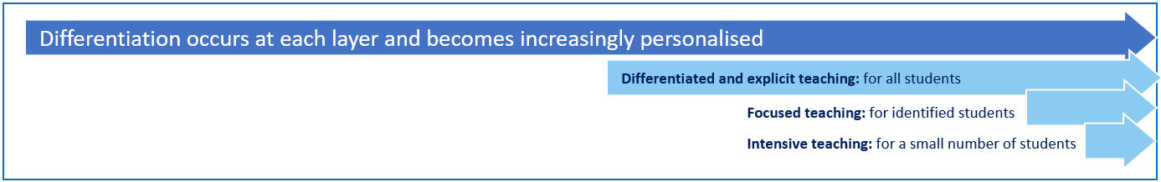

These three layers map directly to the tiered approach discussed earlier in the Learning and Behaviour section. For example, in the PBL framework, Tier 1 is differentiated and explicit teaching for all students, Tier 2 is focussed teaching for identified students and Tier 3 is intensive teaching for a small number of students. Each layer provides progressively more personalised supports for students.

Focused Teaching

Approximately 15% of all students in any school or classroom may require additional support to meet behaviour expectations, even after being provided with differentiated and explicit teaching. These students may have difficulty meeting behavioural expectations in a particular period of the day or as part of a learning area/subject, and focused teaching is provided to help them achieve success.
Class teacher is supported by other school-based staff to address in-class problem behaviour. This may include:
- Functional Behaviour Assessment
- Individual student behaviour support strategies (e.g. Student behaviour plan)
- Targeted skills teaching in small group
- Token economy
- Detention
- Behavioural contract
- Counselling and guidance support
- Self-monitoring plan
- Check in Check Out strategy
- Teacher coaching and debriefing
- Referral to Student Support Network for team based problem solving
- Stakeholder meeting with parents and external agencies

Intensive Teaching

School leadership team work in consultation with Student Support Network to address persistent or ongoing serious problem behaviour. This may include:
- Functional Behaviour Assessment based individual support plan
- Complex case management and review
- Stakeholder meeting with parents and external agencies including regional specialists
- Temporary removal of student property (e.g. mobile phone)
- Short term suspension (up to 10 school days)
- Long term suspension (up to 20 school days)
- Charge related suspension (student has been charged with a serious criminal offence is suspended from school until the charge has been dealt with by the relevant justice authorities)
- Suspension pending exclusion (student is suspended from school pending a decision by the Director-General or delegate (principal) about their exclusion from school)
- Exclusion (student is excluded from a particular state school site, a group of state schools or all state schools in Queensland for a defined period of time or permanently)
- Cancellation of enrolment for students older than compulsory school age who refuse to participate in the educational program provided at the school.

Legislative Delegations
Legislation
In this section of the Murarrie State School Student Code of Conduct, there are links to legislation which influences form and content of Queensland state school discipline procedures.

- Anti-Discrimination Act 1991 (Qld)
- Child Protection Act 1999 (Qld)
- Commonwealth Disability Discrimination Act 1992
- Commonwealth Disability Standards for Education 2005
- Criminal Code Act 1899 (Qld)
- Education (General Provisions) Act 2006
- Education (General Provisions) Regulation 2017
- Human Rights Act 2019 (Qld)
- Information Privacy Act 2009 (Qld)
- Judicial Review Act 1991 (Qld)
- Right to Information Act 2009 (Qld)
- Police Powers and Responsibilities Act 2000 (Qld)
- Workplace Health and Safety Act 2011 (Qld)
- Workplace Health and Safety Regulation 2011 (Cwth)

School Disciplinary Absence (SDA)

A School Disciplinary Absence (SDA) is an enforced period of absence from attending a Queensland state school, applied by the Principal as a consequence to address poor student behaviour. There are four types of SDA:
- Short suspension (1 to 10 school days)
- Long suspension (11 to 20 school days)
- Charge-related suspension
- Exclusion (period of not more than one year or permanently).

At Murarrie State School, the use of any SDA is considered a very serious decision. It is typically only used by the Principal when other options have been exhausted or the student’s behaviour is so dangerous that continued attendance at the school is considered a risk to the safety or wellbeing of the school community.

Parents and students may appeal a long suspension, charge-related suspension or exclusion decision. A review will be conducted by the Director-General or their delegate, and a decision made within 40 schools days to confirm, amend/vary or set aside the original SDA decision by the Principal.

The appeal process is a thorough review of all documentation associated with the SDA decision and provides an opportunity for both the school and the family to present their case in the matter. Time is afforded for collection, dissemination and response to the materials by both the school and the family. It is important that the purpose of the appeal is understood so that expectations are clear, and appropriate supports are in place to ensure students can continue to access their education while completing their SDA.

Re-entry following suspension
Students who are suspended from Murarrie State School may be invited to attend a re-entry meeting on the day of their scheduled return to school. The main purpose of this meeting is to welcome the student, with their parent/s, back to the school. It is not a time to review the student’s behaviour or the decision to suspend, the student has already received a punishment through their disciplinary absence from school. The aim of the re-entry meeting is for school staff to set the student up for future success and strengthen home-school communication.
It is not mandatory for the student or their parents to attend a re-entry meeting. It may be offered as a support for the student to assist in their successful re-engagement in school following suspension.

Arrangements
The invitation to attend the re-entry meeting will be communicated via telephone and in writing, usually via email. Re-entry meetings are short, taking less than 10 minutes, and kept small with only the Principal or their delegate attending with the student and their parent/s. A record of the meeting is saved in OneSchool, under the Contact tab, including any notes or discussions occurring during the meeting.

Structure
The structure of the re-meeting should follow a set agenda, shared in advance with the student and their family. If additional items are raised for discussion, a separate arrangement should be made to meet with the parent/s at a later date and time. This meeting should be narrowly focussed on making the student and their family feel welcome back into the school community.

Possible agenda:
- Welcome back to school
- Check in on student wellbeing
- Discuss any recent changes to school routine or staffing
- Offer information about supports available (e.g. guidance officer)
- Set a date for follow-up
- Thank student and parent/s for attending
- Walk with student to classroom

Reasonable adjustments
In planning the re-entry meeting, school staff will consider reasonable adjustments needed to support the attendance and engagement of the student. This includes selecting an appropriate and accessible meeting space, organising translation or interpretation services or supports (e.g. AUSLAN), provision of written and/or pictorial information and other relevant accommodations. The inclusion of support staff, such as guidance officers or Community Education Counsellors, may also offer important advice to ensure a successful outcome to the re-entry meeting.

School Policies

Murarrie State School has tailored school discipline policies designed to ensure students, staff and visitors work cooperatively to create and maintain a supportive and safe learning environment. Please ensure that you familiarise yourself with the responsibilities for students, staff and visitors outlined in the following policies:

- Temporary removal of student property (Mandated)
- Use of mobile phones and other devices by student (Mandated)
- Preventing and responding to bullying (Mandated)
- Appropriate use of social media (Mandated)

Temporary removal of student property

The removal of any property in a student’s possession may be necessary to promote the caring, safe and supportive learning environment of the school, to maintain and foster mutual respect between all state school staff and students. The Temporary removal of student property by school staff procedure outlines the processes, conditions and responsibilities for state school principals and school staff when temporarily removing student property.
In determining what constitutes a reasonable time to retain student property, the Principal or state school staff will consider:
- the condition, nature or value of the property
- the circumstances in which the property was removed
- the safety of the student from whom the property was removed, other students or staff members
- good management, administration and control of the school.

The Principal or state school staff determine when the temporarily removed student property can be returned, unless the property has been handed to the Queensland Police Service.

Responsibilities

School Staff at Murarrie State School:
- do not require the student’s consent to search school property such as lockers, desks or iPad that are supplied to the student through the school;
- may seize a student’s bag where there is suspicion that the student has a dangerous item (for example, a knife) in their school bag, prior to seeking consent to search from a parent or calling the police;
- consent from the student or parent is required to examine or otherwise deal with the temporarily removed student property. For example, staff who temporarily remove a mobile phone from a student are not authorised to unlock the phone or to read, copy or delete messages stored on the phone;
- there may, however, be emergency circumstances where it is necessary to search a student’s property without the student’s consent or the consent of the student’s parents (e.g. to access an EpiPen for an anaphylactic emergency);

Parents of students at Murarrie State School:
Ensure your children do not bring property onto school grounds or other settings used by the school (e.g. camp, sporting venues) that:
- is illegal
- puts the safety or wellbeing of others at risk
- does not preserve a caring, safe, supportive or productive learning environment
- does not maintain and foster mutual respect;
- collect temporarily removed student property as soon as possible after they have been notified by the Principal or state school staff that the property is available for collection.

Students of Murarrie State School:
Do not bring property onto school grounds or other settings used by the school (e.g. camp, sporting venues) that:
- is illegal
- puts the safety or wellbeing of others at risk
- does not preserve a caring, safe, supportive or productive learning environment
- does not maintain and foster mutual respect;
- collect their property as soon as possible when advised by the Principal or state school staff it is available for collection.

Use of mobile phones and other devices by students

Digital literacy refers to the skills needed to live, learn and work in a society where communication and access to information is dominated by digital technologies like mobile phones. However, the benefits brought about through these diverse technologies can be easily overshadowed by deliberate misuse which harms others or disrupts learning.
This policy reflects the importance the school places on students displaying courtesy, consideration and respect for others whenever they are using personal technology devices.

Mobile Phones and Wearable Devices

On 6 July 2023, Minister Grace announced that all state school students will be required to keep their mobile phones ‘away for the day’ from the beginning of Term 1 2024. This announcement also extends to wearable devices like smartwatches, which can be worn, but must have notifications switched off, so that phone calls, messages and other notifications cannot be sent or received during school hours.
The adoption of this state-wide approach will support schools to maintain a strong focus on educational achievement, and student wellbeing and engagement, by:
- providing optimal learning and teaching environments, free from the distractions caused by personal use of mobile phones and wearable devices
- supporting schools to create safe and supportive learning environments that prioritise student engagement and wellbeing
- encouraging increased face-to-face social interactions between students
- promoting the health and wellbeing of students by providing opportunities for social interaction and physical activity during break times
- reducing the potential for students to be exposed to the negative impacts of the digital world resulting from unsafe or inappropriate use of technology, such as cyberbullying, accessing harmful content or breaches of personal privacy.
At Murarrie State School all mobile phones are to be clearly labelled and given to front office staff at the beginning of the day and collected at 3:00pm. All care but no responsibility will be taken for equipment.
It is unacceptable for students at Murarrie State School to:
- use a mobile phone or other devices in an unlawful manner
- use a mobile phone in technology-free designated spaces or times
- download, distribute or publish offensive messages or pictures
- use obscene, inflammatory, racist, discriminatory or derogatory language
- use language and/or threats of violence that may amount to bullying and/or harassment, or even stalking
- insult, harass or attack others or use obscene or abusive language
- deliberately waste printing and internet resources
- damage computers, printers or network equipment
- commit plagiarism or violate copyright laws
- ignore teacher directions for the use of social media, online email and internet chat
- send chain letters or spam email (junk mail)
- knowingly download viruses or any other programs capable of breaching the department's network security
- use in-phone cameras anywhere a normal camera would be considered inappropriate, such as in change rooms or toilets
- invade someone's privacy by recording personal conversations or daily activities and/or the further distribution (e.g. forwarding, texting, uploading, Bluetooth use etc.) of such material
- use a mobile phone (including those with Bluetooth functionality) to cheat during exams or assessments /take into or use mobile devices at exams or during class assessment unless expressly permitted by school staff.

Confiscation

Permitted personal technology devices used contrary to this policy on school premises will be confiscated by school staff. They will be made available for collection from the school office at the end of the school day unless required to be kept for purposes of disciplinary investigation, when it will only be returned in the presence of a parent.

Devices potentially containing evidence of criminal offences may be reported to the police. In such cases police may take possession of such devices for investigation purposes and students and parents will be advised to contact Queensland Police Service (QPS) directly.

Students who have a personal technology device confiscated more than once will not be permitted to have a personal technology device at school for a time deemed at the Principal’s discretion.

Recording Voice and Images

Every member of the school community should feel confident about participating fully and frankly in all aspects of school life without concern that their personal privacy is being invaded by them being recorded without their knowledge or consent.

We uphold the value of trust and the right to privacy at Murarrie State School. Students using personal technology devices to record inappropriate behaviours or incidents (such as vandalism, fighting, bullying, staged fighting or pranks etc) for the purpose of dissemination among the student body or outside the school, by any means (including distribution by phone or internet posting) builds a culture of distrust and disharmony.

Students must not record images anywhere that recording would not reasonably be considered appropriate (e.g. in change rooms, toilets or any other place where a reasonable person would expect to be afforded privacy).

Recording of events in class is not permitted unless express consent is provided by the school Principal.

A student at school who uses a personal technology device to record private conversations, ordinary school activities or violent, illegal or embarrassing matter capable of bringing the school into public disrepute is considered to be in breach of this policy.

Even where consent is obtained for such recording, the school will not tolerate images or sound captured by personal technology devices on the school premises or elsewhere being disseminated to others. If it is done for the purpose of causing embarrassment to individuals or the school, for the purpose of bullying or harassment, including racial and sexual harassment, or where without such intent a reasonable person would conclude that such outcomes may have or will occur.

Students involved in:
- recording; and/or
- disseminating material (through text messaging, display, internet uploading etc); and/or,
- knowingly being a subject of a recording
Will be in breach of this policy and may be subject to discipline (including suspension and recommendation for exclusion).

Students should note that the recording or dissemination of images that are considered indecent (such as nudity or sexual acts involving children), is against the law and if detected by the school will result in a referral to QPS.

Text Communication
The sending of text messages that contain obscene language and/or threats of violence may amount to bullying and or harassment or even stalking, and will subject the sender to
discipline and possible referral to QPS. Students receiving such text messages at school, should ensure they keep the message as evidence and bring the matter to the attention of the school office.

Recording Private Conversations and the Invasion of Privacy Act 1971
It is important that all members of the school community understand that under the Invasion of Privacy Act 1971, ‘a person is guilty of an offence against this Act if the person uses a listening device to overhear, record, monitor or listen to a private conversation’. It is also an offence under the Act for a person who has overheard, recorded, monitored or listened to a conversation to which s/he is not a party to publish or communicate the substance or meaning of the conversation to others.
Students and families need to understand that some conversations are private and therefore to overhear, record, monitor or listen to such private conversations may be in breach of this Act, unless consent to the recording is appropriately obtained.

Special Circumstances Arrangement
Students who require the use of a personal technology device in circumstances that would contravene this policy (for example to assist with a medical condition or other disability or for a special project) should negotiate a special circumstances arrangement with the Principal.
* Personal Technology Devices includes, but is not limited to, games devices (such as
Portable gaming devices, laptop computers, PDAs, Blackberrys®, cameras and/or voice recording devices (whether or not integrated with a mobile phone or MP3 player), mobile telephones, IPADs® and devices of a similar nature.
Preventing and responding to bullying

Purpose

Murarrie State School uses the Australian Student Wellbeing Framework to promote positive relationships and the wellbeing of all students, staff and visitors at the school.

Our staff know student learning is optimised when they feel connected to others and experience safe and trusting relationships. Students who feel secure are more likely to be active participants in their learning and to achieve better physical, emotional, social and educational outcomes. Teachers who feel valued and supported are more likely to engage positively with students and build stronger connections within the school community. Parents who are positively engaged with their child’s education leads to improved student self-esteem, attendance and behaviour at school. Enhancing the wellbeing of students and their educators delivers overall long-term social, health and economic benefits to the Australian community.

Murarrie State School strives to create positive, predictable environments for all students at all times of the day. The disciplined and teaching environment that we are creating is essential to:
- Achieving overall school improvement, including the effectiveness and efficiency of our student support procedures
- Raising achievement and attendance
- Promoting equality and diversity and
- Ensuring the safety and well-being of all members of the school community.

There is no place for bullying at Murarrie State School. Research indicates that both those being bullied and those who bully are at risk for behavioural, emotional and academic problems. These outcomes are in direct contradiction to our school community’s goals and efforts for supporting all students.

Bullying behaviours that will not be tolerated at Murarrie State School include name-calling, taunting, mocking, making offensive comments, kicking, hitting, pushing, taking belongings, inappropriate text messaging, sending offensive or degrading images by phone or internet, producing offensive graffiti, gossiping, excluding people from groups, and spreading hurtful and untruthful rumours.

Bullying may be related to:
- race, religion or culture
- disability
- appearance or health conditions
- sexual orientation
- sexist or sexual language
- young carers or children in care.

At Murarrie State School there is broad agreement among students, staff, parents and families that bullying is a observable and measurable behaviour. When considering whether or not bullying has occurred, we will avoid speculation on the intent of the behaviour, the power of individuals involved, or the frequency of its occurrence. Whether bullying behaviour is observed between students of equal or unequal power, whether it occurs once or several times, and whether or not the persons involved cite intimidation, revenge, or self-defence as a motive, the behaviour will be responded to in similar fashion, that is, as categorically unacceptable in the school community.

Rationale

Research indicates that many problem behaviours are peer-maintained. That is, peers react to bullying in ways that may increase the likelihood of it occurring again in the future. Reactions include joining in, laughing, or simply standing and watching, rather than intervening to help the person being bullied. Whilst our school would never encourage students to place themselves at risk, our anti-bullying procedures involve teaching the entire school a set of safe and effective responses to all problem behaviour, including bullying, in such a way that those who bully are not socially reinforced for demonstrating it.

The anti-bullying procedures at Murarrie State School are an addition to our already research-validated school-wide positive behaviour support processes. This means that all students are being explicitly taught the expected school behaviours and receiving high levels of social acknowledgement for doing so.

Prevention

Attempting to address specific problem behaviours will not be successful if the general level of disruptive behaviour in all areas of our school is not kept to a low level. Therefore, our school-wide universal behaviour support practices will be maintained at all times. This will ensure that:

- Our universal behaviour support processes will always remain the primary strategy for preventing problem behaviour, including preventing the subset of bullying behaviour
- All students have been or are being taught the specific routines in the non-classroom areas, from exiting the classroom, conducting themselves in accordance with the school expectations in the playground and other areas, to re-entering their classrooms
- All students are receiving high levels of positive reinforcement for demonstrating expected behaviours, including those associated with following our routines, from all staff in the non-classroom areas of the school
- A high level of quality active supervision is a permanent staff routine in the non-classroom areas. This means that duty staff members are easily identifiable and are constantly moving, scanning and positively interacting as they move through the designated supervision sectors of the non-classroom areas.

Murarrie State School also uses behavioural data for decision-making. This data is entered into One School on a daily basis and can be recalled as summary reports at any time. This facility is one way the school can track the effectiveness of its anti-bullying process, to make any necessary adjustments, and to identify specific bullying behaviours that may need to be revisited or revised in the instructional process

Bullying response flowchart for teachers
Key contacts for students and parents to report bullying:
Prep to Year 6 – Class teacher
Principal : principal@murarriess.eq.edu.au

Cyberbullying
First hour
Listen
- Provide a safe, quiet space to talk
- Reassure the student that you will listen to them
- Let them share their experience and feelings without interruption
- If you hold immediate concerns for the student's safety, let the student know how you will address these. Immediate in this circumstance is where the staff member believes the student is likely to experience harm (from others or self) within the next 24 hours
- Continue to check in with student on regular basis until concerns have been mitigated
- Record notes of follow-up meetings in OneSchool
- Refer matter to specialist staff within 48 hours if problems escalate
- Look for opportunities to improve school wellbeing for all students
Ongoing
Follow up
- Evaluate the information to determine if bullying has occurred or if another disciplinary matter is at issue
- Make a time to meet with the student to discuss next steps
- Ask the student what they believe will help address the situation
- Provide the student and parent with information about student support network
- Agree to a plan of action and timeline for the student, parent and yourself
Day three
Discuss
- Ask the student for examples they have of the alleged bullying (e.g. hand written notes or screenshots)
- Write a record of your communication with the student
- Check back with the student to ensure you have the facts correct
- Enter the record in OneSchool
- Notify parent/s that the issue of concern is being investigated
Day one
Document
- Gather additional information from other students, staff or family
- Review any previous reports or records for students involved
- Make sure you can answer who, what, where, when and how
- Clarify information with student and check on their wellbeing
Day two
Collect
- Document the plan of action in OneSchool
- Complete all actions agreed with student and parent within agreed timeframes
- Monitor the student and check in regularly on their wellbeing
- Seek assistance from student support network if needed
Day four
Implement
- Meet with the student to review situation
- Discuss what has changed, improved or worsened
- Explore other options for strengthening student wellbeing or safety
- Report back to parent
- Record outcomes in OneSchool
Day five
Review

Cyberbullying is treated at Murarrie State School with the same level of seriousness as in-person bullying. The major difference with cyberbullying however, is that unlike in-person bulling, cyberbullying follows students into their community, their homes and their bedrooms, giving them no opportunity to escape the harassment or abuse during the evening, weekends or holidays.

In the first instance, students or parents who wish to make a report about cyberbullying should approach the regular class teacher (for students in primary year levels)

It is important for students, parents and staff to know that state school principals have the authority to take disciplinary action to address student behaviours that occur outside of school hours or school grounds. This includes cyberbullying. Parents and students who have concerns about cyberbullying incidents occurring during school holidays should immediately seek assistance through the Office of the e-Safety Commissioner or the Queensland Police Service.

Students enrolled at Murarrie State School may face in-school disciplinary action, such as detention or removing of privileges, or more serious consequences such as suspension or exclusion from school for engaging in behaviour that adversely affects, or is likely to adversely affect, other students or the good order and management of the school. This includes behaviour such as cyberbullying which occurs outside of school hours or settings, for example on the weekend or during school holidays. It also applies to inappropriate online behaviour of enrolled students that is directed towards other community members or students from other school sites.

Parents or other stakeholders who engage in inappropriate online behaviour towards students, staff or other parents may be referred to the Office of the e-Safety Commissioner and/or the Queensland Police Service. State school staff will be referred for investigation to the Integrity and Employee Relations team in the Department of Education.

Appropriate use of social media

The department acknowledges the growing popularity of social media both as a communication and educational tool and supports its appropriate use. It also acknowledges the potential for damage to be caused (either directly or indirectly) to students, families and staff through the inappropriate use of social media. Students must understand they are responsible for the content they publish on social media platforms so it is important they understand what is expected of them while using social media. This section of the Student Code of Conduct clearly details what behaviour is expected of students, how this will be reinforced and possible consequences for failing to meet these standards.

Cyberbullying is treated at Murarrie State School with the same level of seriousness as in-person bullying. The major difference with cyberbullying however, is that unlike in-person bulling, cyberbullying follows students into their community, their homes and their bedrooms, giving them no opportunity to escape the harassment or abuse during the evening, weekends or holidays.

In the first instance, students or parents who wish to make a report about cyberbullying should approach the regular class teacher.
It is important for students, parents, families and staff to know that state school Principals have the authority to take disciplinary action to address student behaviours that occur outside of school hours or school grounds. This includes cyberbullying. Parents and students who have concerns about cyberbullying incidents occurring during school holidays should immediately seek assistance through the Office of the e-Safety Commissioner or the Queensland Police Service.

Students enrolled at Murarrie State School may face in-school disciplinary action, such as detention or removing of privileges, or more serious consequences such as suspension or exclusion from school for engaging in behaviour that adversely affects, or is likely to adversely affect, other students or the good order and management of the school. This includes behaviour such as cyberbullying which occurs outside of school hours or settings, for example on the weekend or during school holidays. It also applies to inappropriate online behaviour of enrolled students that is directed towards other community members or students from other school sites.

Cyberbullying response flowchart for school staff

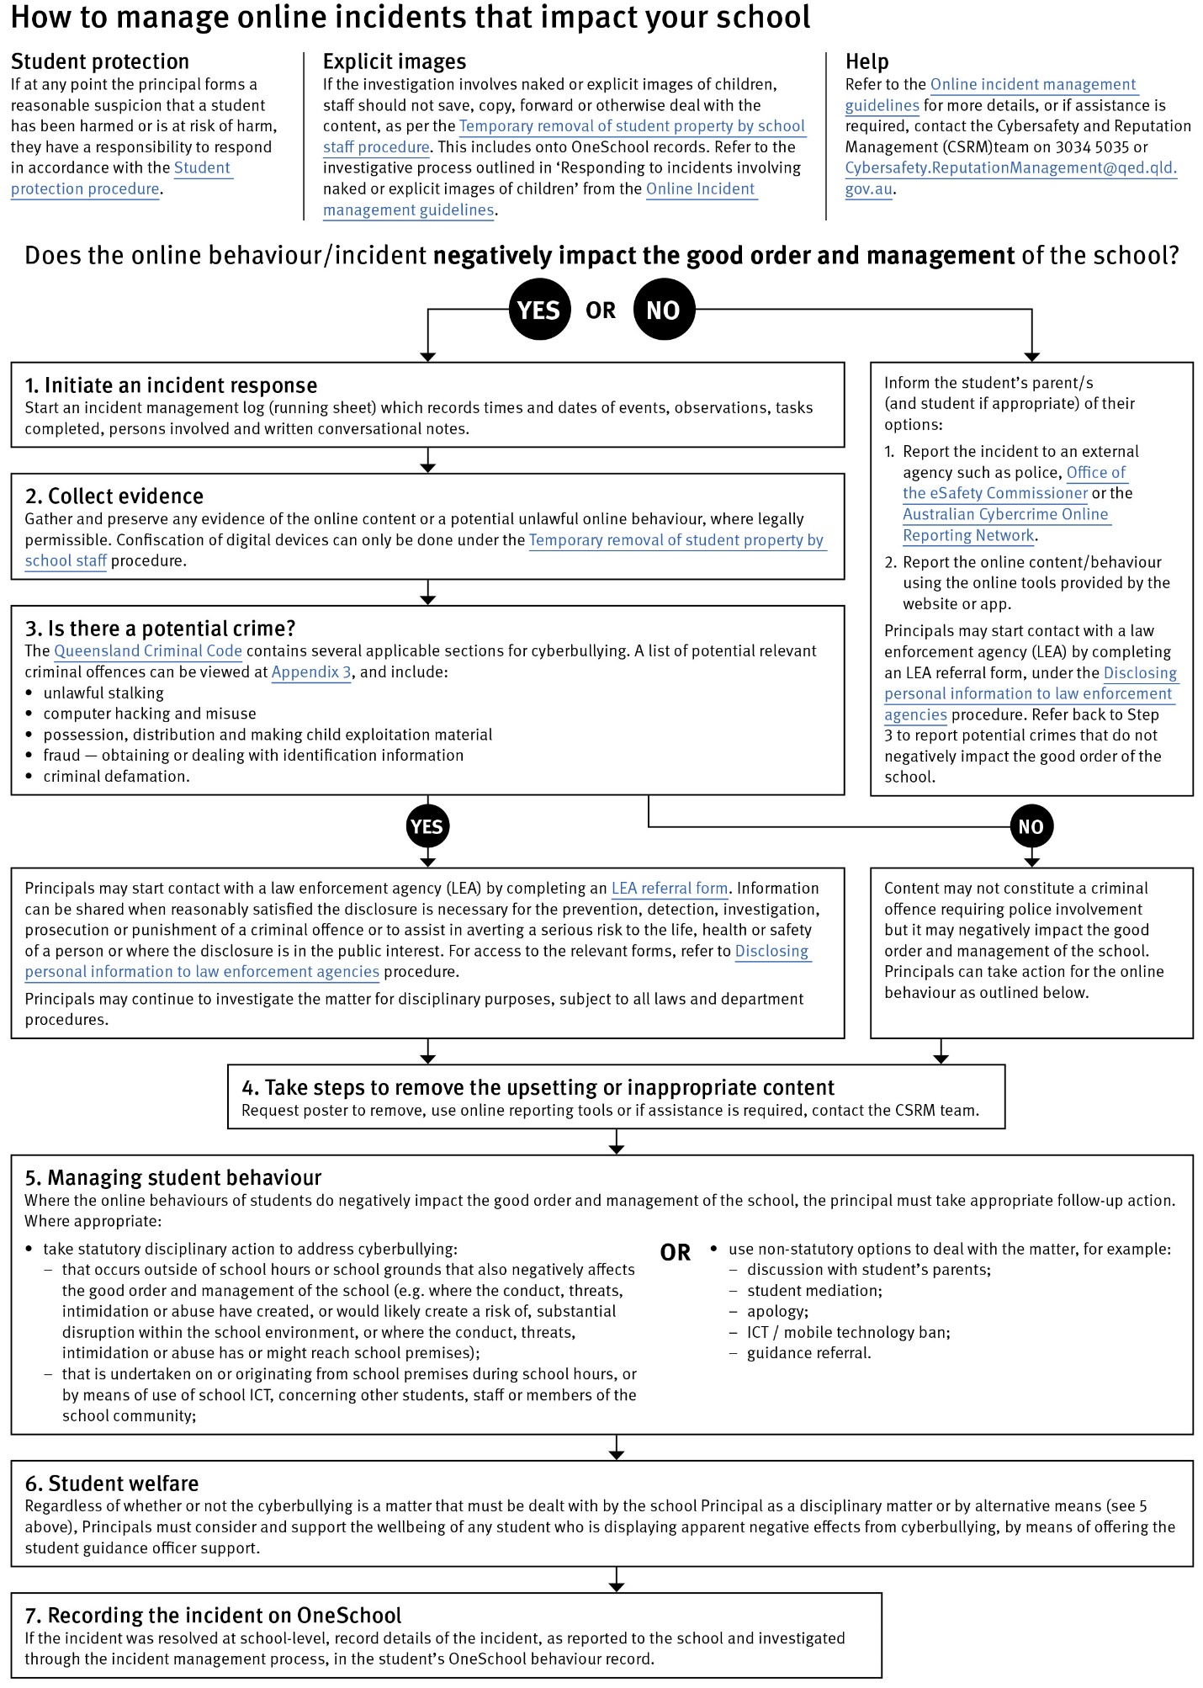

Cybersafety and Reputation Management (CRM)

The Department of Education employs a dedicated team of experts to assist in maintaining the integrity of the department's reputation with regards to cybersafety and reputation management issues, effectively leading the development and implementation of departmental cybersafety processes.

This team provides direct support for schools to respond to concerns of inappropriate online behaviour and misuse of information and communication technology.

The team provides a guide for parents with important information about cybersafety and cyberbullying, and suggestions about what you can do if your child is a target or responsible for inappropriate online behaviour.

The team has also developed a Cyberbullying and reputation management (Department employees only) resource to assist principals in incident management.

For more information about cybersafety sessions at your school, or for assistance with issues relating to online behaviour, contact the team (Department employees only).

Restrictive Practices

School staff at Murarrie State School need to respond to student behaviour that presents a risk of physical harm to the student themselves or others. It is anticipated that most instances of risky behaviour can be de-escalated and resolved quickly. On some rarer occasions, a student’s behaviour may continue to escalate and staff need to engage immediately with positive and proactive strategies aimed at supporting the student to manage their emotional arousal and behaviour.

In some very rare situations, where there is immediate risk of physical harm to the student or other people, and when all other alternative strategies have failed to reduce the risk, it may be necessary for staff to use restrictive practices.

The use of restrictive practices will always be as a last resort, when there is no other available option for reducing immediate risk to the student, staff or other people. Restrictive practices are not used for punishment or as a disciplinary measure.

The department’s Restrictive practices procedure is written with consideration for the protection of everyone’s human rights, health, safety and welfare. There are six fundamental principles:

- Regard to the human rights of those students
- Safeguards students, staff and others from harm
- Ensures transparency and accountability
- Places importance on communication and consultation with parents and carers
- Maximises the opportunity for positive outcomes, and
- Aims to reduce or eliminate the use of restrictive practices.

Very rarely restrictive practices will be planned and staff will employ, when necessary, pre-arranged strategies and methods (of physical restraint/ mechanical restraint/ clinical holding) which are based upon behaviour risk assessment or clinical health need and are recorded in advance. The use of planned strategies will only be where there is foreseeable immediate risk consistent with the Restrictive Practice procedure.

Restrictive practices procedure.

Seclusion will not be used as a planned response and will only be used in serious circumstances for managing an unforeseeable situation in an emergency. It will be used for the shortest time possible and in a safe area that presents no additional foreseeable risk to the student. In such emergencies, a staff member will observe the student at all times and seclusion will cease as soon as possible.

Following the use of any restrictive practice, a focused review will help staff to understand how they responded to the risk in any incident that involved the use of a restrictive practice. Staff will consider whether there are other options for managing a similar situation in the future. This strategy works well for reducing the use of restrictive practices.

All incidents of restrictive practices will be recorded and reported in line with departmental procedures.

Physical Intervention
Staff may make legitimate use of physical intervention if all non-physical interventions have been exhausted and a student is
- physically assaulting another student or staff member
- posing an immediate danger to him/herself or to others.

NB: All incidents involving physical intervention by Department of Education staff MUST be reported to the Principal within 1 hour. Administration will ensure parents/ carers are informed of any incidents involving their child.

Appropriate physical intervention may be used to ensure that Murarrie State School’s duty of care to protect students and staff from foreseeable risks of injury is met. The use of physical intervention is only considered appropriate where the immediate safety of others is threatened and the strategy is used to prevent injury.

Physical intervention can involve coming between students, blocking a student’s path, leading a student by the hand/arm, shepherding a student by placing a hand in the centre of the upper back, removing potentially dangerous objects and, in extreme situations, using more forceful restraint.

It is important that all staff understand:
• physical intervention cannot be used as a form of punishment
• physical intervention must not be used when a less severe response can effectively resolve the situation
• the underlying function of the behaviour.

Physical intervention is not to be used as a response to:
• property destruction
• school disruption
• refusal to comply
• verbal threats
• leaving a classroom or the school, unless student safety is clearly threatened.

Any physical intervention made must:
• be reasonable in the particular circumstances
• be in proportion to the circumstances of the incident
• always be the minimum force needed to achieve the desired result, and
• take into account the age, stature, disability, understanding and gender of the student.

Containment
Containment can be used as a short term planned strategy with individual students as part of period of initial assessment when a student is new to the school and there is evidence that the student presents a risk of harm to themselves or other people
- a period of settling into a new environment or reintegration to school after a period of absence when there is evidence that the student presents a risk of harm to themselves or other people
- intensive short-term support in response to frequent behaviour presenting a risk of harm to the student or other people.
Containment will not be relied on as a long-term strategy and the use will be time limited. There must be a plan to evidence how and when the containment will be reduced and when it will cease to be used.

Mechanical restraint
Mechanical restraint can be used as a planned restrictive practice for reducing or controlling a student’s serious and repetitive self-injurious behaviour. Mechanical restraint should only be implemented when:
- there is a foreseeable risk of harm to the student through self-injurious behaviour
- the advice of an appropriately qualified health professional has been sought about the use of the device within the school or educational setting and they have prescribed the use of the device for responding to a specific behaviour
- other less restrictive approaches have been tried or considered for managing the risk of the behaviour and found to be ineffective at reducing risk
- parents have approved the use of mechanical restraint

There is a plan for the use of the mechanical restraint that has been prepared in consultation with an appropriately qualified health professional and included in the student’s Individual Student Safety Plan, and state school staff have received training in how to use the prescribed device from an appropriately qualified health professional or person/ organisation nominated by the health professional
The Restrictive Practice procedure does not apply to the appropriate use of devices (below):
- to enable the safe transportation of a student in a vehicle (e.g. booster seat)
- to prevent injury from involuntary bodily movement (e.g. head support or brace (head pod)
- and to provide postural support, or surgical/medical device for the proper treatment of a physical condition (e.g. wheelchair lap straps to prevent falls and maintain posture).

Chemical Restraint

State school staff must not use any chemical restraint to control or subdue a student's behaviour. However, state school staff may administer medications that are prescribed by a health professional for the student in accordance with Administration of medications in schools procedure. For a student who has prescribed emergency medication for their health condition, if the medication is required, state school staff should administer it to the student with reference to the student’s Emergency Health Plan or Action Plan and their "Administration of Medication at School Record Sheet" (see Guidelines for the administration of medication in schools).

Focus Review

Formal debriefing should be led by a staff member trained in the process who has not been involved in the event. The goals are to:
• Reverse or minimise the negative effects of physical intervention
• Prevent the future use of physical intervention
• Address organisational problems and make appropriate changes

Critical Incidents

It is important that all school staff at Murarrie State School have a consistent understanding of how to respond in emergencies involving student behaviour that seriously endangers the student or others. This consistency ensures that appropriate actions are taken to ensure that both students and staff are kept safe.

A critical incident is defined as an occurrence that is sudden, urgent, and usually unexpected, or an occasion requiring immediate action (e.g. in the community, on the road). The aim in these situations is to bring the behaviour of the student under rapid and safe control. It is not a time to try and to punish or discipline the student; it is a crisis management period only.

Staff should follow the documented plan for any student involved in regular critical incidents, which should be saved and available for staff to review in OneSchool.

For unexpected critical incidents, staff should use basic defusing techniques:

- Avoid escalating the problem behaviour: Avoid shouting, cornering the student, moving into the student’s space, touching or grabbing the student, sudden responses, sarcasm, becoming defensive, communicating anger and frustration through body language.

- Maintain calmness, respect and detachment: Model the behaviour you want students to adopt, stay calm and controlled, use a serious measured tone, choose your language carefully, be matter of fact and avoid responding emotionally.

- Approach the student in a non-threatening manner: Move slowly and deliberately toward the problem situation, speak privately to the student/s where possible, speak calmly and respectfully, minimise body language, keep a reasonable distance, establish eye level position, be brief, stay with the agenda, acknowledge cooperation, withdraw if the situation escalates.

- Follow through: If the student starts displaying the appropriate behaviour briefly acknowledge their choice and re-direct other students’ attention towards their usual work/activity. If the student continues with the problem behaviour, then remind them of the expected school behaviour and identify consequences of continued unacceptable behaviour.

- Debrief: At an appropriate time when there is low risk of re-escalation, help the student to identify the sequence of events that led to the unacceptable behaviour, pinpoint decision moments during the sequence of events, evaluate decisions made, and identify acceptable decision options for future situations

Related Procedures and Guidelines
These are related procedures or guidelines which school staff use to inform decisions and actions around matters associated with students wellbeing, behaviour and learning.

- Cancellation of enrolment
- Complex case management
- Customer complaints management policy and procedure
- Disclosing personal information to law enforcement agencies
- Enrolment in state primary, secondary and special schools
- Hostile people on school premises, wilful disturbance and trespass
- Inclusive education
- Police and Child Safety Officer interviews and searches with students
- Restrictive practices
- Refusal to enrol – Risk to safety or wellbeing
- Student discipline
- Student dress code
- Student protection
- Supporting students’ mental health and wellbeing
- Temporary removal of student property by school staff
- Use of ICT systems
- Using mobile devices

Resources

- Australian Professional Standards for Teachers

- Bullying. No Way!

- eheadspace

- Kids Helpline

- Office of the eSafety Commissioner

- Parent and community engagement framework

- Parentline

- Queensland Department of Education School Discipline

- Raising Children Network

- Student Wellbeing Hub

Conclusion

Murarrie State School staff are committed to ensuring every student is supported to feel safe, welcome and valued in our school. There may, however, be occasions where parents need to raise a concern or make a complaint about an issue you feel is adversely affecting their child's education.
All Queensland state schools are committed to ensuring that all complaints - whether they relate to a school staff member or a school's operations - are dealt with in a fair and equitable manner. As a parent or carer, you can express dissatisfaction with the service or action of the Department of Education or its staff, including decisions made or actions taken in a school and/or by the local regional office.

As a complainant, it is your responsibility to:
- give us a clear idea of the issue or concern and your desired solution
- provide all the relevant information when making the complaint
- understand that addressing a complaint can take time
- cooperate respectfully and understand that unreasonable, abusive, or disrespectful conduct will not be tolerated
- let us know if something changes, including if help is no longer needed.

The Department of Education may not proceed with your complaint if your conduct is unreasonable.
In most instances, staff members are told of complaints made about them and offered the right of reply. A complainant also has the right to have a support person throughout the process.
The following three-step approach assists parents and school staff in reaching an outcome that is in the best interests of the student:

- Early resolution: discuss your complaint with the school
The best place to raise any concerns is at the point where the problem or issue arose. You can make an appointment at the school to discuss your complaint with your child’s teacher or the principal. You are also welcome to lodge your complaint in writing or over the phone. You can also make a complaint through QGov.

Complaints may be lodged by telephone, writing or in electronic format. Email addresses can be accessed through the schools directory.

- Internal review: contact the local Regional Office
If, after taking the early resolution step, you are dissatisfied with the outcome of your complaint or how the complaint was handled, you can ask the local regional office to conduct a review. You need to submit a Request for internal review form within 28 days of receiving the complaint outcome.
- External review: contact a review authority
if you are dissatisfied after the internal review, you may wish to contact a review authority, such as the Queensland Ombudsman, and request an independent, external review. More information about external review options is available at www.ombudsman.qld.gov.au.

Some matters need to be handled in a different way to school matters and will be referred to other areas in the department. These include: issues about harm, or risk of harm, to a student attending a state school, which must be managed in accordance with the Student protection procedure
- complaints about corrupt conduct, public interest disclosures; or certain decisions made under legislation, which will be dealt with as outlined in the Complaints and grievances management policy.

